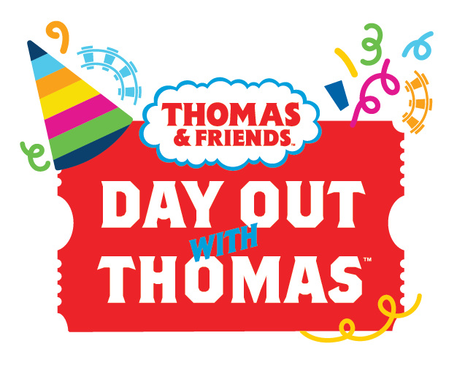

DAY OUT WITH THOMAS™ IS PULLING INTO THE NORTHWEST RAILWAY MUSEUM FOR AN OUTDOOR PARTY YOU WON’T WANT TO MISS!

(Snoqualmie, WA, June 10, 2021)— All aboard! Day Out With Thomas featuring Thomas the Tank Engine returns to Snoqualmie, in his only Pacific Northwest tour stop, at the Northwest Railway Museum on July 9-11 and 16-18, 2021.

With health and safety protocols in place, this fun-filled event offers families the opportunity to hop on board an interactive train ride with a life-sized Thomas the Tank Engine! Fun family activities include a hay maze, live entertainment, photo opportunities, a bubble zone and more. Children will receive a take home goody bag of Thomas themed fun, and can say “hello” to Sir Topham Hatt, the Railway Controller from The Island of Sodor. There will be Thomas themed activities at the Train Shed Exhibit Hall area and fun things to see at the Historic Snoqualmie Depot. Visitors can check out the pop-up gift shop for exclusive Thomas swag! We’re back on track for delivering fun and memories! Capacity will be limited and advanced tickets are required. Everyone with a ticket receives a free admission for a follow-up visit to the Museum’s Train Shed Exhibit Hall this summer!

WHO: Thomas the Tank Engine with the Party Train Tour

WHAT: Day Out With Thomas highlights include:
- Two train rides pulled by a full-sized, talking Thomas the Tank Engine locomotive from Snoqualmie Depot to the Railway History Campus, where guests explore activities for an hour and another train ride to the top of scenic Snoqualmie Falls.
- Activities and entertainment included!
- Free Admission for a follow-up visit to the Museum’s Train Shed Exhibit Hall this summer!
- Say hello to Sir Topham Hatt, Controller of the Railway.
- Each child receives a take home goody bag of fun.
- Pop-up gift shop on-site with exclusive Thomas & Friends products only available at Day Out With Thomas.

ENHANCED SAFETY MEASURES: The health and well-being of our guests and employees is our primary concern, and we have made the following adjustments to ensure all can safely enjoy Thomas’ party. Some of the measures in place for Day Out With Thomas include:
- Masks required for guests ages 5 and up event (Masks recommended for guests ages 2-4)
- Limited capacity entry to the event, allowing for safe distances to be maintained throughout the event and aboard train ride.
- Advanced tickets required, sold at https://Thomas.TrainMuseum.org

WHEN: July 9-11 and 16-18, 2021

TIME: Select your designated train departure time when purchasing tickets at https://Thomas.TrainMuseum.org

WHERE: Trains depart at your ticketed time from the Northwest Railway Museum’s Snoqualmie Depot, 38625 SE King St, Snoqualmie, WA 98065.

Tickets for an unforgettable day at Day Out With Thomas are on sale NOW, and are available at https://Thomas.TrainMuseum.org . Ticket prices are $21-$28 for ages 2 and up (service charges and fees may apply). Advanced tickets are required. Walk-up sales will not be available.

For more information and directions, contact Northwest Railway Museum at 425.888.3030 x 7202 AND TrainMuseum.org
For more information about Thomas & Friends please visit: www.thomasandfriends.com, www.facebook.com/thomasandfriends and for bonus material and exclusive content www.youtube.com/user/thomasandfriends.

###

Media Contact:
Richard Anderson
Richard@TrainMuseum.org
425-301-1566

